Manufacturing Blend Adjustment Analysis
Context/Objective
Adjustments are modifications made to a blend to bring it within specification. Because they add manufacturing time and may require extra material outside the original schedule, the purpose of this review is to identify where adjustment burden is concentrated and where time-saving improvements should be prioritized.
Executive Takeaway
Adjustment burden is concentrated in a relatively small subset of product groups, tanks, and operating contexts. The analysis indicates that the highest total burden and the highest adjustment-rate burden are not always the same, meaning both total workload and proportional instability should be considered when prioritizing review. In some cases, elevated burden appears to reflect structural operating constraints rather than simple underperformance, making operational context important when interpreting the results.
Key Findings
- Adjustment burden is heavily concentrated by product group, with Soaps & Detergents and Dressings accounting for the majority of all recorded adjustments.
- The highest total adjustment burden and the highest adjustment-rate burden do not always point to the same tanks, indicating that some tanks create more total work while others are less reliable proportionally.
- A small number of tank / tank-size combinations account for a disproportionate share of total adjustments, suggesting that the burden is concentrated in a limited set of operating contexts.
- Trend analysis shows that the adjustment activity is variable over time rather than steadily improving, which suggests that instability exists throughout the manufacturing process.
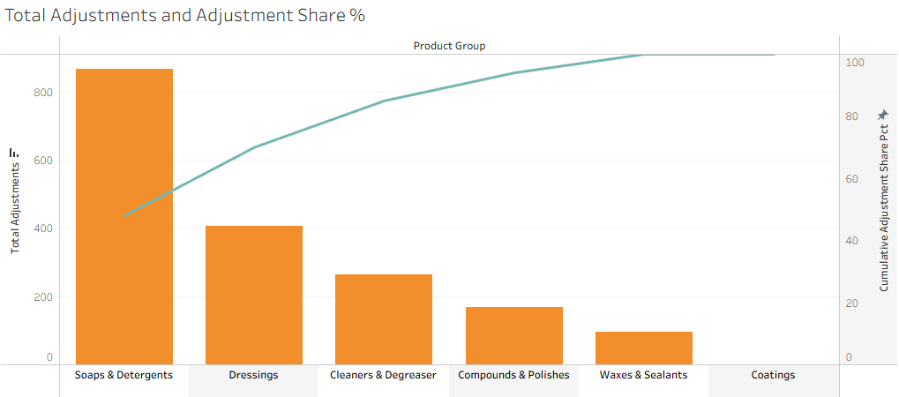

Priority Review Areas
Product Groups
Prioritize review of the highest-burden product groups, especially Soaps & Detergents and Dressings, as these categories account for the largest share of all recorded adjustments and represent the biggest sources of recurring process burden.
Tanks / Tank-Size Contexts
Prioritize review of the tank / tank-size combinations contributing the largest share of total adjustments. These combinations represent the most concentrated sources of operational burden and should be reviewed before lower-impact contexts.
Tank-level results should also be interpreted with operational context. Tank 1 carries the highest total adjustment burden, but this appears to be influenced in part by its use of an air motor for solvent-safe manufacturing. Because that setup is operationally necessary for certain blends, Tank 1 should not be treated as directly comparable to a general-use tank.
Areas
Area-level results should be used to identify where adjustment burden and instability are clustering operationally. The Mezzanine stands out as the primary burden area, while the Skirt warrants targeted review because its relatively small maximum blend size limits throughput while still consuming meaningful manufacturing and lab time.
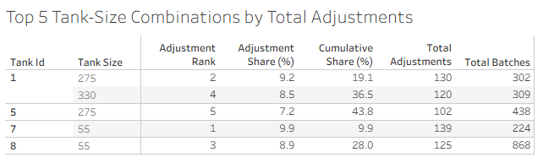
The top 5 tank / tank-size combinations account for a disproportionate share of total adjustments, making them the most immediate candidates for targeted review.

Tank Burden Summary
Tank-level results show that the highest total adjustment burden and the highest adjustment-rate burden do not always point to the same operating context. Some tanks generate the most total adjustments because they support a larger share of production activity, while others stand out because a larger proportion of their batches require intervention. This distinction is important when prioritizing review, since total burden and proportional instability indicate different types of operational concern.
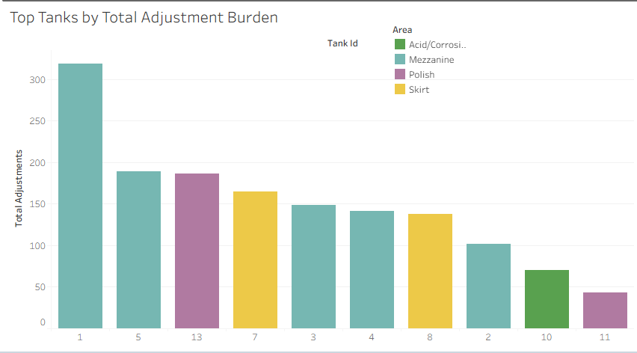

Trend Summary
Time-based analysis shows that adjustment burden has fluctuated over the observed period rather than moving in a consistently downward direction. Rolling averages indicate periods of improvement followed by renewed increases, suggesting that performance remains variable and should continue to be monitored.
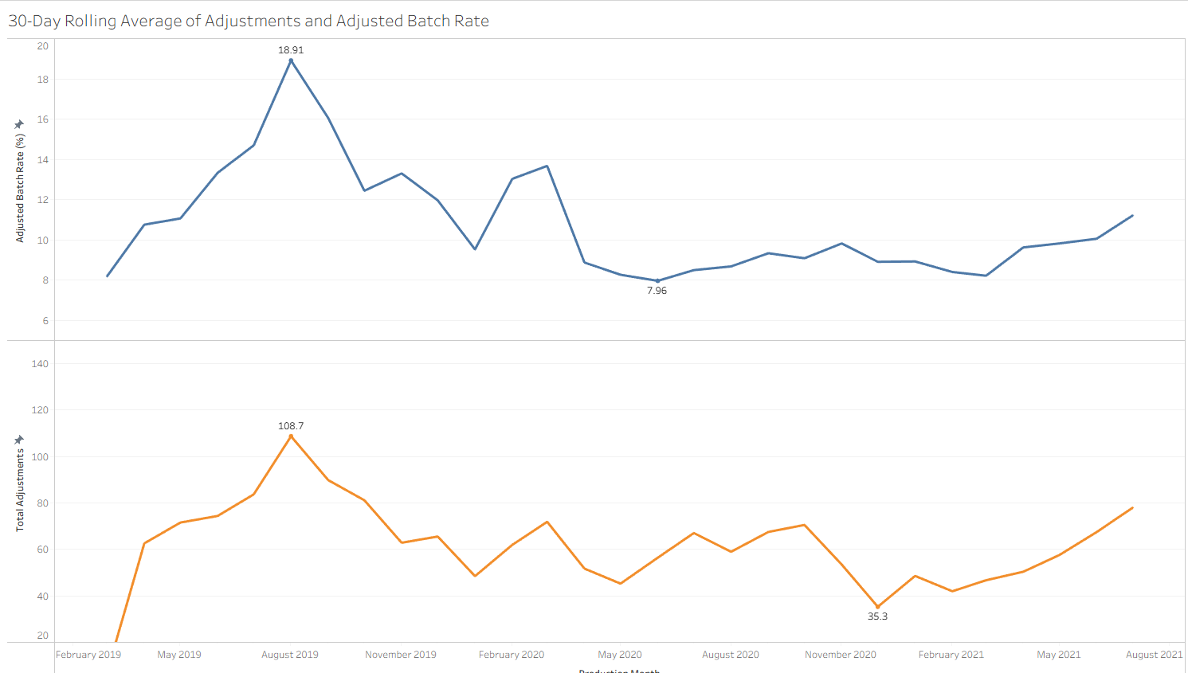
Operational Implication
These results suggest that adjustment burden is concentrated rather than evenly distributed. Broad process review across all operations is less likely to be effective than targeted review focused on the highest-contributing product groups, tank / tank-size contexts, and operating areas. In some cases, elevated burden may reflect structural operating constraints rather than simple underperformance, which makes context important when prioritizing action.
Limitations
• Rankings identify where burden is concentrated, but do not by themselves determine root cause.
• Tank, area, and product-group performance should still be interpreted alongside operational context and production mix. Tanks supporting higher-volume or more adjustment-prone categories may naturally show higher total burden.
• Additional review would be needed to distinguish whether burden is driven primarily by equipment, formulation, scheduling, or other process factors.

Recommendations
- High-burden product groups: Review Soaps & Detergents and Dressings for recurring formulation or process issues, as these groups account for the largest share of total adjustment burden.
- Tank 1: Use Tank 1 for non-solvent blends only when operationally necessary. Where possible, reserve it for solvent-based production or safer-fit categories such as cleaners and degreasers.
- Skirt Area: Evaluate whether the Skirt area remains operationally necessary. Its limited maximum blend size, combined with elevated adjustment burden, may make it a comparatively inefficient use of manufacturing and lab resources.
- Performance monitoring: Use the 30-day rolling trend as an ongoing KPI to track whether adjustment burden is improving after operational changes are made.
- Material cost impact: Extend the analysis to measure how adjustments affect total blend cost, especially where added material is not reflected in the original schedule. This would require additional material usage and cost data.

